CDL WEEK 5 – INTRODUCTION TO FLEX

PHIROZGAR IRANI
230905370
CSE VI – B
B2 batch – R.No. 45

Q1. Count the number of vowels and consonants in the given input.
CODE:
%{
#include <stdio.h>
int vowels = 0, consonants = 0;
%}

%%
[aeiouAEIOU] { vowels++; }
[a-zA-Z] { consonants++; }
\n ;
. ;
%%

int yywrap()
{return 1;}

int main() {
yylex();
printf("Vowels = %d\n", vowels);
printf("Consonants = %d\n", consonants);
return 0;
}

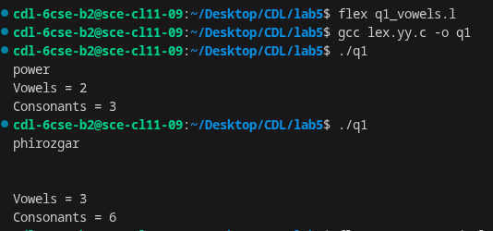

Q2. Count the number of words, characters, blanks and lines in a given text.
CODE:
%{
#include <stdio.h>
int words = 0, chars = 0, blanks = 0, lines = 0;
%}

%%
[ \t] { blanks++; chars++; }
\n { lines++; chars++; }
[^ \t\n]+ { words++; chars += yyleng; }
. { chars++; }
%%

int yywrap()
{return 1;}

int main() {
yylex();
printf("Words = %d\n", words);
printf("Characters = %d\n", chars);
printf("Blanks = %d\n", blanks);
printf("Lines = %d\n", lines);
return 0;
}
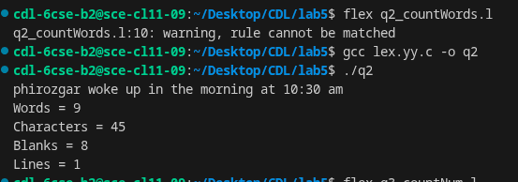

Q3. Find the number of positive integer, negative integer, positive floating positive number and negative floating point number
CODE:
%{
#include <stdio.h>
int pos_int=0, neg_int=0, pos_float=0, neg_float=0;
%}

%%
[-]?[0-9]+"."[0-9]+ {
if(yytext[0]=='-') neg_float++;
else pos_float++;
}
[-]?[0-9]+ {
if(yytext[0]=='-') neg_int++;
else pos_int++;
}
\n ;
. ;
%%

int yywrap()
{return 1;}

int main() {
yylex();
printf("Positive Integers = %d\n", pos_int);
printf("Negative Integers = %d\n", neg_int);
printf("Positive Floats = %d\n", pos_float);
printf("Negative Floats = %d\n", neg_float);
return 0;
}
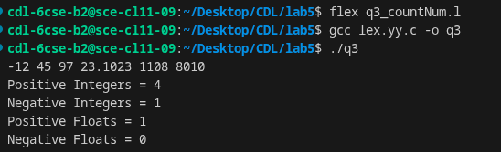

Q4. Given a input C file, replace all scanf with READ and printf with WRITE statements also find the number of scanf and printf in the file.
CODE:
%{
#include <stdio.h>
int sc = 0, pr = 0;
%}

%%
scanf { sc++; printf("READ"); }
printf { pr++; printf("WRITE"); }
.|\n { printf("%s", yytext); }
%%

int yywrap()
{return 1;}

int main() {
yylex();
printf("\nNumber of scanf = %d\n", sc);
printf("Number of printf = %d\n", pr);
return 0;
}
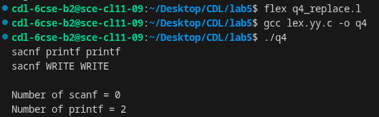
Q5. That changes a number from decimal to hexadecimal notation.
CODE:
%{
#include <stdio.h>
%}

%%
[0-9]+ {
int n = atoi(yytext);
printf("0x%X", n);
}
\n { printf("\n"); }
. { printf("%s", yytext); }
%%

int yywrap()
{return 1;}

int main() {
yylex();
return 0;
}
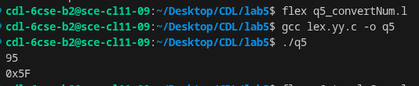

Q6. Convert uppercase characters to lowercase characters of C file excluding the characters present in the comment.
CODE:
%{
#include <stdio.h>
%}

%%
"//".* { printf("%s", yytext); }
"/*"([^*]|\*+[^*/])*\*+"/" { printf("%s", yytext); }
[A-Z] { printf("%c", tolower(yytext[0])); }
.|\n { printf("%s", yytext); }
%%

int yywrap()
{return 1;}

int main() {
yylex();
return 0;
}
